In this report, I am summarizing what I learnt from the assigned reading and applying that on a project from Kaggle. Due to my interest and enthusiasm toward the nature, I searched for the US wildfire data. This dataset, which can be found [here](https://www.kaggle.com/rtatman/188-million-us-wildfires/notebooks), summarizes 24 years of geo-referenced wildfire records. The time-series and geo essences of this dataset make a perfect setting for this dataset to be used in geospatial visualization. Understandably, the dataset is huge.

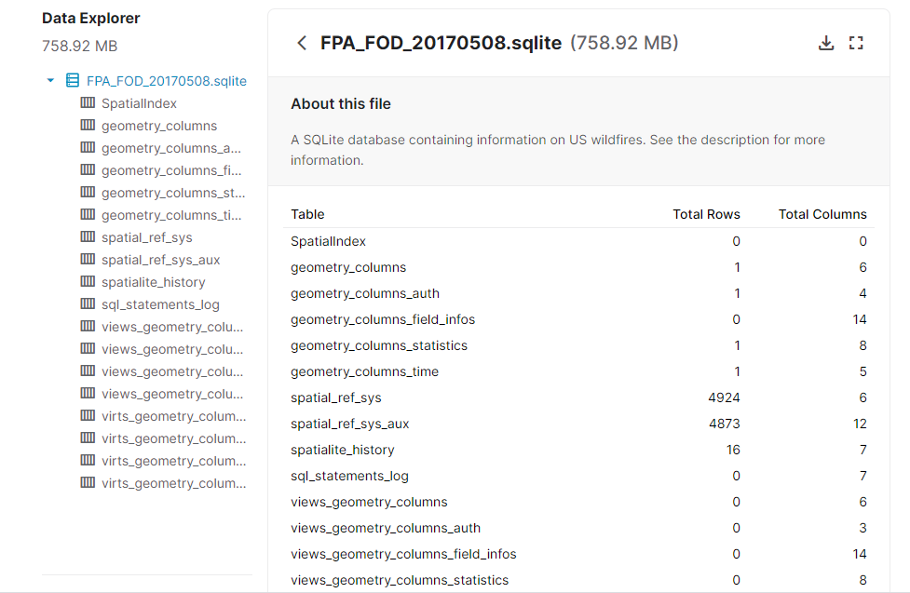

According to the dataset description, the database contains the spatial records of wildfires that occurred between 1992 and 2015 in the United States.

In my opinion, considering the nature of the dataset, I believe 0D and 1D visualizations, something like choropleth scaled down to location of wildfires that shows the occurrence of a wildfire in a given time, which can be controlled with a time controller could be used in this dataset. In addition, a 1D visualization where we use a bar on each location that shows the number of lasting days of that fire in the given location could be also used. In fact, this model would be the 1D model of the aforementioned 0D model where the time controller is dissolved in the new visualization.